Creating a splinter of a project
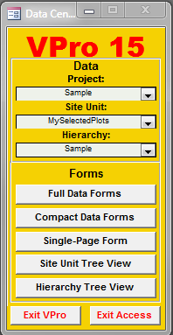
Creating a splinter of a project involves creating a new project with some or all of the plots in the original project. The selection of the plots to be included in the splinter is limited by the plots in the current site unit table. For example if you have 51 plots in your current project and 33 plots in your current site unit table, your splinter project will contain 33 plots. Of course this assumes your project contains the plots listed in your site unit table.
Let’s run through an example using the sample data and a site unit table that contains 33 plots.
You first need to select the project that contains the plots you want to include in the splinter. The next step is to select the site unit table that contains just the plots you wish to copy into your new splinter project.

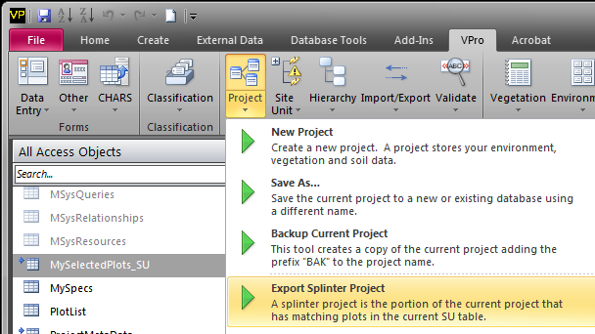
Now, from the VPro section of the ribbon menu, click Project and then select Export Splinter Project.

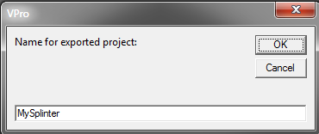
You will be asked for a name for your new project.

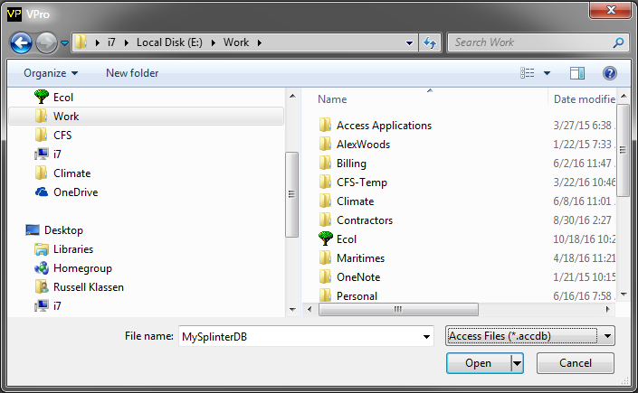
You need to save the splinter project in either an existing Access database or enter a name for a new database.

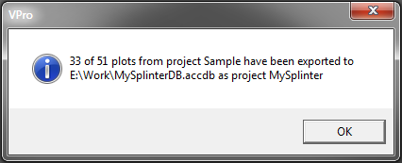
You will receive confirmation once the export is complete.

Note that you will need to attach the splinter project to start using it in VPro.

